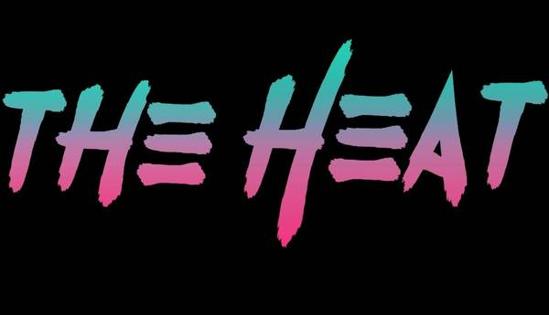 

[**www.TheHeat80s.com**](http://www.TheHeat80s.com)  **www.TheHeat80s.com**

**2025 HK’s Bar & Grill Schedule 2025 HK’s Bar & Grill Schedule**

**9740 19Th St. Rancho Cucamonga CA 91737 9740 19Th St. Rancho Cucamonga CA 91737**

**All Shows are 6:00pm to 10:00pm All Shows are 6:00pm to 10:00pm**

**2025 2025**

**March 1st 2025 March 1st 2025**

**April 5th 2025 April 5th 2025**

**May 17th 2025 May 17th 2025**

**June 7th 2025 June 7th 2025**

** **

[**www.TheHeat80s.com**](http://www.TheHeat80s.com)  **www.TheHeat80s.com**

**2025 HK’s Bar & Grill Schedule 2025 HK’s Bar & Grill Schedule**

**9740 19Th St. Rancho Cucamonga CA 91737 9740 19Th St. Rancho Cucamonga CA 91737**

**All Shows are 6:00pm to 10:00pm All Shows are 6:00pm to 10:00pm**

**2025 2025**

**March 1st 2025 March 1st 2025**

**April 5th 2025 April 5th 2025**

**May 17th 2025 May 17th 2025**

**June 7th 2025 June 7th 2025**