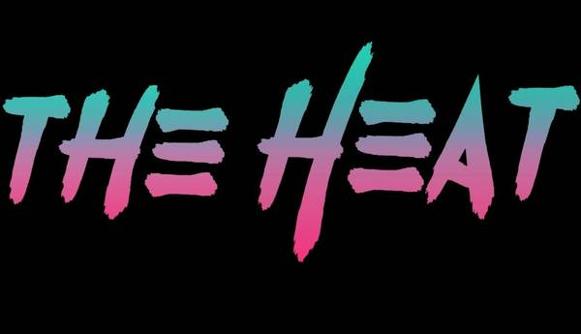

**www.TheHeat80s.com**

**The Heat – HK’s Bar & Grill Set List 11/16/2024**

**Set 1**

**1- Summer Of 69**

**2 – The Stroke**

**\*\*Guitar change\*\***

**3 – Hit Me With Your Best Shot**

**4 – Dancin With Myself**

**\*\*Guitar change\*\***

**5 – Hungry Like The Wolf**

**\*\*Guitar change\*\***

**6 - New Sensation**

**7 - White Wedding**

**\*\*Guitar change\*\***

**8 - Separate Ways**

**9 – Everybody Wants You**

**10 – Fight For Your Right**

**11 – Rebel Yell**

** www.TheHeat80s.com**

**The Heat – HK’s Bar & Grill Set List 11/16/2024**

**Set 2**

**1 - Your Love**

**2 – Jenny Jenny 867-5309**

**3 - Hurts So Good**

**\*\*Guitar change\*\***

**4 - I Love Rock & Roll**

**4 - Mony Mony**

**6 - What I Like About You**

**7 - R.O.C.K. In The USA**

**8 – Anyway You Want It**

**\*\*Guitar change\*\***

**9 - Don’t Stop Believin**

**10 – I Want You To Want Me**

**11 – Anything Anything**



**www.TheHeat80s.com**

**The Heat – HK’s Bar & Grill Set List 11/16/2024**

**Set 3**

**1 – Livin After Midnight**

**2 - Breakin The Law**

**3 – You Really Got Me**

**\*\*Guitar change\*\***

**5 - Here I Go Again**

**6 - Runnin With The Devil**

**7 – Fallen Angel**

**\*\*Guitar change\*\***

**7 - Runaway**

**8 – Talk Dirty To Me**

**9 - Ain’t Talkin Bout Love**

**\*\*Guitar change\*\***

**10 - You Give Love A Bad Name**



**www.TheHeat80s.com**

**The Heat – HK’s Bar & Grill Set List 11/16/2024**

**Set 4**

**1 – Girls Girls Girls**

**2 - Rock Of Ages**

**3 – Crazy Train**

**\*\*Guitar change\*\***

**4 - Jump**

**5 - Panama**

**6 - Animal**

**\*\*Guitar change\*\***

**7 - Don’t Stop Believin**

**8 - Nothin But A Good Time**

**9 - Pour Some Sugar On Me**

**\*\*Guitar change\*\***

**10 - Livin On A Prayer**

**11 - Sweet Child Of Mine**

**Extra**

**1 – Round And Round**

**2 – Kickstart My Heart**

**3 – Wanted Dead Or Alive**