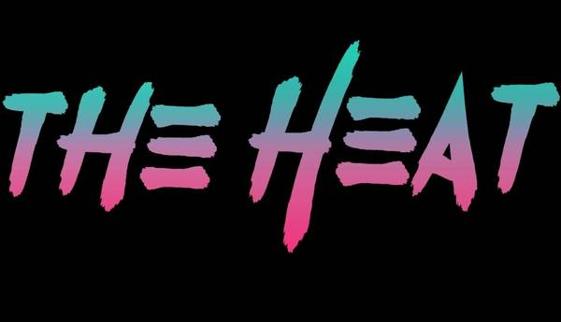

**www.TheHeat80s.com**

**The Heat – HK’s Bar & Grill Set List 8/24/2024**

**Set 1**

**1- Talk Dirty To Me**

**2 - Everybody Wants You**

**3 - Summer Of 69**

**4 - Panama**

**5 - Livin After Midnight**

**6 - Jessie’s Girl**

**7 - Round And Round**

**8 - Rockin In The Free World**

**9 – Wanted Dead Or Alive**

**10 - Crazy Train**

** www.TheHeat80s.com**

**The Heat – HK’s Bar & Grill Set List 8/24/2024**

**Set 2**

**1 - Separate Ways**

**2 – New Sensation**

**3 - Your Love**

**4 - You Really Got Me**

**5 - White Wedding**

**6 - Breakin The Law**

**7 - The Stroke**

**8 - Runnin With The Devil**

**9 - Fight For Your Right**

**10 - Rebel Yell**



**www.TheHeat80s.com**

**The Heat – HK’s Bar & Grill Set List 8/24/2024**

**Set 3**

**1 – Runaway**

**2 - Here I Go Again**

**3 - I Love Rock & Roll**

**4 - Pour Some Sugar On Me**

**5 - I Want You To Want Me**

**6 - Don’t Stop Believing**

**7 - Hurts So Good**

**8 - What I Like About You**

**9 - R.O.C.K. In The USA**

**10 - Nothin But A Good Time**

**11 - Livin On A Prayer**



**www.TheHeat80s.com**

**The Heat – HK’s Bar & Grill Set List 8/24/2024**

**Set 4**

**1 - Animal**

**2 - Rock Of Ages**

**3 - Jenny Jenny 867-5309**

**4 - Mony Mony**

**5 - Anything Anything**

**6 - Jump**

**7 - You Give Love A Bad Name**

**8 - Ain’t Talkin Bout Love**

**9 - Sweet Child Of Mine**