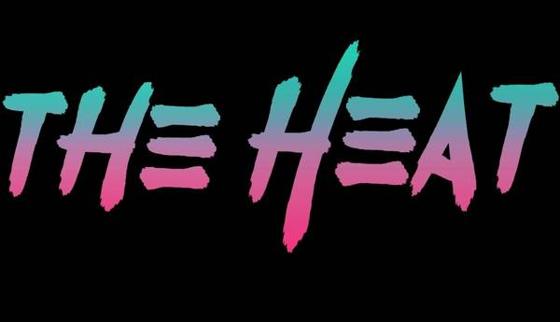

**www.TheHeat80s.com**

**The Heat – Stone Church Brewery Set List 8/3/2024**

**Set 1**

**1- Talk Dirty To Me**

**2 - You Really Got Me**

**3 - Everybody Wants You**

**4 - Crazy Train**

**5 - White Wedding**

**6 - Anything Anything**

**7 - Jump**

**8 - Animal**

**9 - New Sensation**

**10 - Don’t Stop Believing**

**11 - You Give Love A Bad Name**

** www.TheHeat80s.com**

**The Heat – Stone Church Brewery Set List 8/3/2024**

**Set 2**

**1 - Your Love**

**2 - Panama**

**3 - Nothin But A Good Time**

**4 - Pour Some Sugar On Me**

**5 - What I Like About You**

**6 - R.O.C.K. In The USA**

**7 - I Love Rock & Roll**

**8 - Mony Mony**

**9 - I Want You To Want Me**

**10 - Jenny Jenny 867-5309**

**11 - Hurts So Good**

**12 - Don’t Change**

**13 - Livin On A Prayer**

**14 - Sweet Child Of Mine**



**www.TheHeat80s.com**

**The Heat – Stone Church Brewery Set List 8/3/2024**

**Set 3**

**1 - Rock Of Ages**

**2 - Separate Ways**

**3 - Runnin With The Devil**

**4 - Breakin The Law**

**5 - Here I Go Again**

**6 - Round And Round**

**7 - Rockin In The Free World**

**8 - Rebel Yell**

**9 - Ain’t Talkin Bout Love**

**10 - Livin After Midnight**



**www.TheHeat80s.com**

**The Heat – Stone Church Brewery Set List 8/3/2024**

**Set 4**

**1 - Jessie’s Girl**

**2 - Kickstart My Heart**

**3 - Summer Of 69**

**4 - Fight For Your Right**

**5 - The Stroke**

**6 - Play That Funky Music**