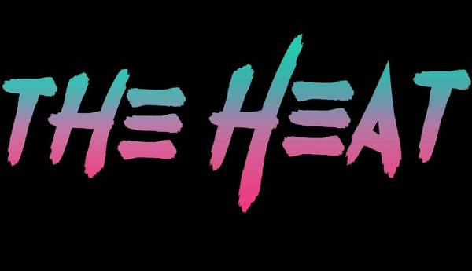
www.TheHeat80s.com
The Heat – HK’s Bar & Grill Set List 4/5/2025
Set 1
1- Summer Of 69
2 – Hit Me With Your Best Shot
3 – The Stroke
**Guitar change**
4 – Hungry Like The Wolf
5 – Dancin With Myself
6 - New Sensation
7 - White Wedding
**Dave - Guitar change**
8 – Just Like Heaven
**Guitar change**
9 - Separate Ways
10 – Everybody Wants You
11 – Fight For Your Right
12 – Rebel Yell

www.TheHeat80s.com
The Heat – HK’s Bar & Grill Set List 4/5/2025
Set 2
1 – Jenny Jenny 867-5309
2 - Your Love
3 - Mony Mony
4 - I Love Rock & Roll
5 - Hurts So Good
6 – Don’t You Forget About Me
7 - What I Like About You – ROCK in USA
8 – Anyway You Want It
**Guitar change**
9 - Don’t Stop Believin
10 – I Want You To Want Me
11 – She Sells Sanctuary
12 - You Give Love A Bad Name

www.TheHeat80s.com
The Heat – HK’s Bar & Grill Set List 4/5/2025
Set 3
1 – Livin After Midnight
2 - Breakin The Law
3 – Round And Round
4 – You Really Got Me
**Guitar change**
5 - Here I Go Again
6 - Runnin With The Devil
7 – Fallen Angel
**Guitar change**
8 - Runaway
9 - Ain’t Talkin Bout Love
10 – Talk Dirty To Me
11 – Anything Anything

www.TheHeat80s.com
The Heat – HK’s Bar & Grill Set List 4/5/2025
Set 4
1 – Girls Girls Girls
2 - Rock Of Ages
3 – Crazy Train
4 - Animal
**Guitar change**
5 - Jump
6 - Panama
**Guitar change**
7 – Kickstart My Heart
8 - Nothin But A Good Time
9 - Pour Some Sugar On Me
10 - Livin On A Prayer
11 - Sweet Child Of Mine

